**Jameson Warranty & Returns**

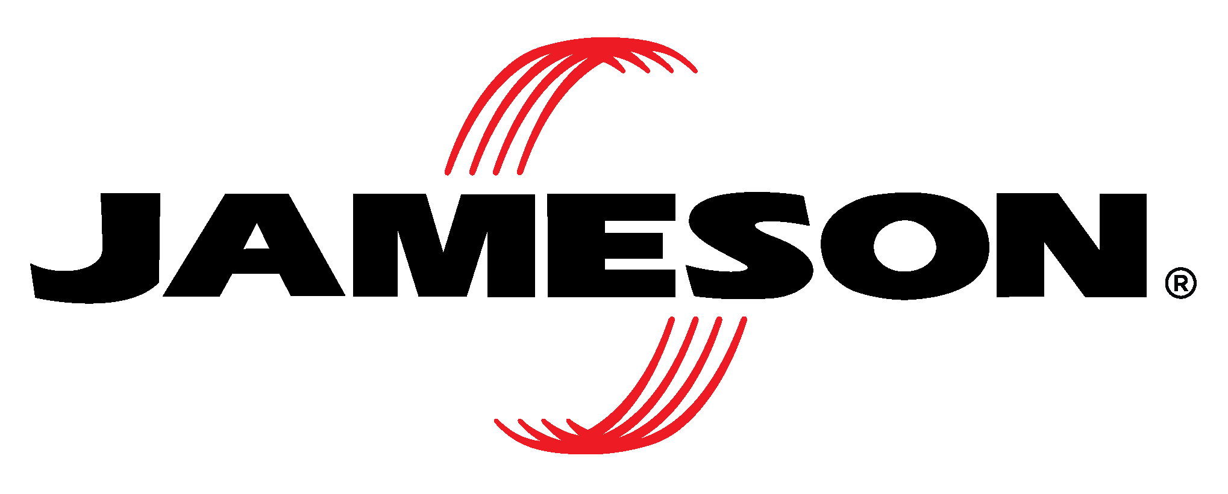

**Limited Warranty**

Jameson products are backed by a warranty against defects in material and workmanship for **one year from the date of shipment**, except in cases of misuse or improper application.

Jameson is not responsible for modifications, alterations, misapplications, or repairs made by the purchaser or any third party. This warranty covers **repair or replacement of the product only** and does not include shipping costs or other related expenses.

**Jameson disclaims all other express or implied warranties, including any implied warranties of merchantability or fitness for a particular purpose.**

For warranty claims, contact **Jameson Customer Service at 800-346-1956.**

**Warranty Returns**

To qualify for credit or exchange, warranty returns must meet the following requirements:

* All returns must include a **Return Goods Authorization (RGA) form**. A copy of the RGA should be included with the return shipment.
* To initiate a return, contact **Jameson Customer Service at 800-346-1956** or email **Orders@JamesonTools.com**.

Once the product is received at Jameson’s facility, it will be evaluated. If covered under warranty, a **replacement or credit** will be issued. If not covered, the product will be returned to the customer with an explanation.

**Warranty Exceptions**

Certain Jameson products carry extended warranties:

* **HDI Heavy Duty Illumination LED Equipment Lights** – **3-year warranty**
* **XD Extreme Duty LED Equipment Lights** – **5-year warranty**
* **ITL Insulated Hand Tools** – **Limited Lifetime Warranty**

For any questions regarding warranties, returns, or product support, don’t hesitate to reach out to Jameson Customer Service.